**OFFICIAL COORDINATION REQUEST FOR**

**NON-ROUTINE OPERATIONS AND MAINTENANCE**

**COORDINATION TITLE** - 15 IHR 014 Ice Harbor Dam Study 6.2.5. **UPDATE.**

**COORDINATION DATE-** 26 August 2015

**PROJECT-** Ice Harbor Dam

**RESPONSE DATE-** 03 September 2015

**Description of the problem: UPDATE.**

In support of the Ice Harbor turbine replacement program, baseline Sensor Fish data were collected in turbine unit 1 in November 2014; however, with limited daylight, poor weather conditions and difficulty recapturing Sensor Fish released through Unit 1, a second effort is needed to collect the remainder of Sensor Fish data. Work in 2014 was coordinated under the 2014 Fish Passage Pan, Appendix A, Section 6.2.1 and MOC14 IHR 009 Ice Harbor Dam Study 6.2.1.

Study dates in the 2015 FPP Appendix A (see Section 6.2.5) were for January, 2015, with coordination of operations and dates through Ice Harbor and FPOM. Due to collection channel maintenance requirements, the second data collection effort has been moved to September, 2015, to allow for acceptable tailrace and environmental conditions. Equipment installation was complete 14 August, 2015, and was coordinated under MOC 15 IHR 010.

Testing turbine unit 1 at generator limit (approximately 14.1kcfs, 102 MW) is planned for 2 days. It is expected that no more than 3 days of operation at this high discharge will be required if a make-up day is needed at the end of the study period. While there is little difference in unit discharge at upper 1% (~13.4 kcfs, 98 MW) and generator limit (~14.1 kcfs, 102 MW), testing generator limit is intended to provide an observation of the difference in the turbine environment between the existing runner at this discharge and the equivalent discharge of the new fixed blade runner at the upper 1% operation.

Sensors will be recaptured in the tailrace, which may require boat access to the BRZ.

**Type of outage required:**  No further unplanned outages are required for equipment installation or removal. Release pipes will be removed from unit 1 in November during the scheduled unit 1 annual maintenance outage.

**Impact on facility operation:** Sensor Fish data collection requires Operator support in maintaining test conditions on the schedule provided below. Mean river flow typically exceeds approximately 18kcfs, but in a low flow year flows may drop near 15kcfs (Figure 1). Should low flow be problematic, the Operator will need to communicate this with the research crew so that testing may be adjusted as appropriate. No further support is anticipated until the Project removes screens in November. Release pipe removal from the screens will be coordinated appropriately to avoid any conflict with the Project maintenance schedule.

Proposed Schedule:

* 1. Test – BOP/design limit for fish passage (87 MW): Sept 9 – 11, 2015
  2. Test – Peak Efficiency (72 MW): Sept 14, 2015
  3. Test – Lower 1% (62 MW): Sept 15 – 18, 2015
  4. Test – Upper 1%/Gen Limit (102 MW): Oct 6 – 7, 2015
  5. Removal of Release Pipes: Nov 2015

**Length of time for repairs:** NA

**Expected impacts on fish passage:**

**Juvenile Passage:** There is expected to be minimal impact to juvenile passage and survival during testing. There are very few fall Chinook (Figure 2A) or steelhead smolts (Figure 2B) outmigrating during the proposed timeframe. It is estimated that ≤ 0.02% of the total juvenile fall Chinook and 0% of juvenile steelhead runs will pass Ice Harbor during the generator limit operation based on ten year average smolt monitoring data for the last few days of September at Lower Monumental Dam (DART 2015). Operations data from the past several years suggests at least two units will operate without spill in early September (GDACS 2015). Therefore, it is estimated that approximately 0.002% of outmigrating fall Chinook may pass unit 1 during the generator limit operation, assuming a low estimate of approximately 77% (Moursund et al. 2004) fish guidance efficiency. Turbine survival estimates have ranged from 88% (Absolon et al. 2005) to 96% (Normandeau 2008) for radio telemetry and balloon tag studies, respectively; therefore, it is reasonable to assume no measurable impact to juvenile salmonid passage and survival.

**Adult Passage:** There are no expected impacts on adult salmonid attraction or passage at the south fishway resulting from testing unit 1 at the upper 1%/Generator Limit.

**Comments from agencies**

-----Original Message-----  
From: Tom Lorz [mailto:lort@critfc.org]   
Sent: Thursday, August 27, 2015 10:53 AM  
To: Bailey, John C NWW  
Cc: gary.fredricks@noaa.gov; trevor.conder@noaa.gov  
Subject: [EXTERNAL] Re: MOC 15 IHR 014 Ice Harbor Dam Study 6.2.5 update 26AUG2015

This should really be done later in the year or outside fish passage season not only from juvenile but any adult fall back stand point. That being said do we really need to test both BOP and Upper 1% gen limit???? is there really much difference to the point that the sensor fish will be able to detect. Did not see mega watt range in the document so what is the difference between these twp ops. At the least might want to think about doing upper 1% last. Also what is the purpose of lower 1% just to get the whole range?????

-----Original Message-----  
From: Trevor Conder - NOAA Federal [mailto:trevor.conder@noaa.gov]   
Sent: Wednesday, September 02, 2015 2:13 PM  
To: Bailey, John C NWW  
Cc: Gary Fredricks - NOAA Federal; Tom Lorz; Trumbo, Bradly A (Bradly) NWW; Bill Hevlin - NOAA Federal  
Subject: [EXTERNAL] Re: MOC 15 IHR 014 Ice Harbor Dam Study 6.2.5 update 26AUG2015

John,

Since unit 1 will go out in November, is there any chance this work could be done later (late Sept, Oct.) when the data generally indicates lower fish passage numbers? If not, I agree with Tom's suggestion of testing Gen limit/1% as late as possible in the schedule given there is still some uncertainty on the effects of that operation. It sounds like two days should be more than enough time to test the Gen limit op.

-Trevor

**Final results:**

Thank you,

Brad Trumbo

Fishery Biologist

Walla Walla District

[bradly.a.trumbo@usace.army.mil](mailto:bradly.a.trumbo@usace.army.mil)

509-527-7253

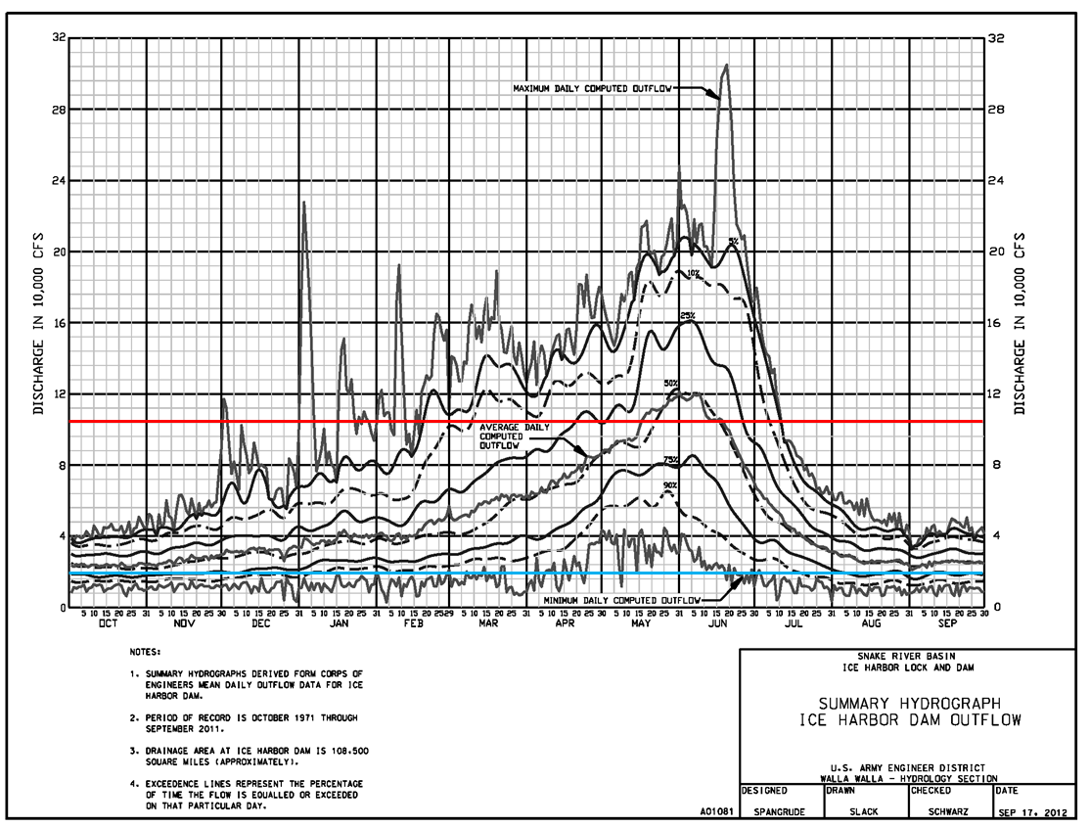

**Figure 1.** Ice Harbor Dam forty year mean daily discharge with exceedence curves for the period of October 1971-September 2011. Discharge is presented in 8 kcfs increments. The red line represents the powerhouse hydraulic capacity at approximately 106 kcfs and the blue line represent extremely low flow at approximately 18 kcfs.

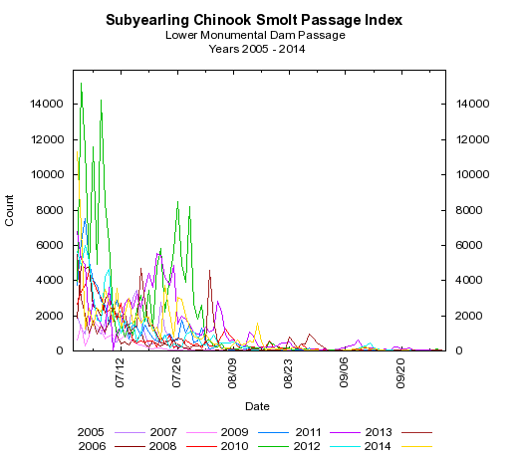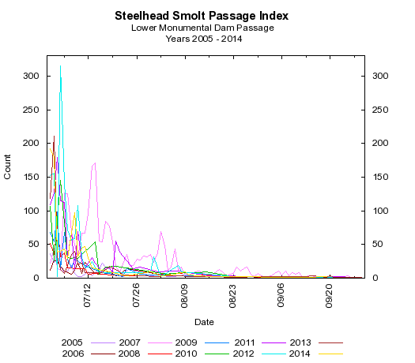

A

B

**Figure 2.** Smolt passage index for subyearling fall Chinook **(A)** and juvenile steelhead **(B)** at Lower Monumental Dam, 2005 – 2014. This data suggests that ≤ 0.04% of the total juvenile fall Chinook and ≤ 0.0002% of juvenile steelhead runs will pass Ice Harbor during the generator limit operation September 9 – 10. It is estimated that approximately 0.008% of outmigrating fall Chinook may pass unit 1 during the generator limit operation.

References:

Absolon RF, BP Sandford, BM Eppard, DA Brege, KW McIntyre, EE Hockersmith, and GM Matthews.

2005. Relative Survival Estimates for PIT-tagged Juvenile Chinook Salmon Passing Through

Turbines, Collection Channels, and Spillways at Ice Harbor Dam, 2003. Report of the National Marine Fisheries Service, Seattle, Washington, for the U.S. Army Corps of Engineers, Walla Walla District, Walla Walla, Washington.

Columbia River DART. 2015. Columbia Basin Research, University of Washington. Available from <http://www.cbr.washington.edu/dart>

Generic Data Acquisition and Control System (GDACS). 2015. <http://nww-wmlocal2.nww.usace.army.mil/nww/gdacs/www/index.html>.

Moursund RA, KD Ham, PS Titzler, and F Khan. 2004. Hydroacoustic Evaluation of the Effects of Spill

Treatments on Fish Passage at Ice Harbor Dam in 2003. PNWD-3420, Report of Battelle-Pacific

Northwest Division, Richland, Washington, for the U.S. Army Corps of Engineers Walla Walla

District, Walla Walla, Washington.

Normandeau Associates, Inc. 2008. Turbine operational effects on survival/condition of yearling Chinook salmon, *Oncorhynchus tshawytscha,* at Ice Harbor Dam, March 2007. Report Prepared for the US Army Corps of Engineers, Walla Walla District, Walla Walla, Washington.